Error Tolerant Adder Type-1 Application in Facial Recognition
O V Gnana Swathika, V S Hitesh, David Alappat.

Abstract:
Getting deep learning models to run on resource constrained edge devices is notoriously difficult; they tend to chew through battery life and struggle with latency. To get around this bottleneck, we explored a slightly different approach: deploying an 8 bit hybrid Error Tolerant Adder Type-1 (ETA-1) architecture directly into the facial recognition pipeline. Instead of forcing the system to rely on traditional, power hungry arithmetic units, we swapped in software modeled ETA-1 logic specifically for the Manhattan Distance ($L1$ Norm) calculations. This is the computationally heavy step where a live face scan is compared against the stored database templates.
The hardware level simulations yielded stark results. We saw a 42.3% drop in energy consumption, alongside a 41.3% improvement in propagation delay when stacked up against standard Ripple Carry Adders. Of course, the inevitable catch with approximate arithmetic is a loss in precision. However, when evaluating the system, the biometric classification accuracy only took a 1.7% hit dropping from our 98.5% baseline down to 96.8%. This seems to suggest that the inherent structural resilience of neural networks can easily absorb minor mathematical errors at the hardware level. Ultimately, for devices like battery powered attendance scanners or smart cameras, trading less than 2% of classification accuracy for a massive 40% reduction in energy overhead appears to be a highly practical, real world compromise.
Keywords:
Approximate Computing, VLSI Design, Error Resilient Systems, Facial Recognition, Deep Learning, CNN Embeddings, Manhattan Distance (L1 Norm), Biometric Accuracy, Edge AI Acceleration, Power Delay Product (PDP).
1.Introduction:
It's no secret that AI is everywhere right now, but pushing complex Convolutional Neural Networks (CNNs) straight onto edge hardware is a bit of an engineering nightmare. The sheer volume of arithmetic required is staggering. If you try to run these networks using standard, exact logic, the processor essentially overheats and drains the battery in no time. For anything mobile or resource limited like a smart doorbell or a handheld scanner that kind of energy demand is basically a nonstarter.
So, how do we get around this bottleneck? We started looking into approximate computing. It turns out that for high level classification tasks, perfect mathematical precision is likely overkill. Because deep neural networks are structurally pretty resilient, they seem to absorb small arithmetic errors without totally dropping the ball on overall pattern recognition. If you can figure out where to cut corners safely, like simplifying the adder logic in the less critical data paths you can actually save a massive amount of silicon area and keep power dissipation under control.
That is essentially what this research tries to tackle. We built an 8 bit hybrid approximate adder using Error Tolerant Adder Type-1 (ETA-1) logic, tailoring it specifically for a facial recognition pipeline. Throughout this paper, we evaluate the real world tradeoffs in a fully simulated end-to-end setup. We wanted to see exactly how much hardware efficiency we could buy, and whether the inevitable drop in biometric accuracy is a price worth paying.

2.Methodology:
At its core, this study is about seeing what happens when you intentionally inject software modeled approximate arithmetic into the classification layer of a Convolutional Neural Network (CNN). When you're dealing with edge computing, think smart locks or wireless security cameras you are constantly fighting battery life. Because of this, hardware design tends to be a balancing act. Our main goal here is to evaluate that exact tradeoff: how much computational accuracy might we have to sacrifice to squeeze out some much needed hardware efficiency?
To actually test this, we completely overhauled the usual pipeline. Instead of relying on standard, perfectly exact accumulation units, we swapped them out for an Error Tolerant Adder Type-1 (ETA-1) variant. We essentially force this modified adder to handle the heavy lifting of calculating the similarity metrics between facial embeddings. Since the math behind this can get a bit abstract, we also put together an interactive, open source simulation interface. It gives a pretty clear, hand on visual of how the bits are actually partitioned and how the arithmetic errors tend to propagate while the system is under an active workload. If you want a quick visual breakdown of how this all comes together, we've mapped out the entire workflow in Figure 1.
Below is a link to demonstrate the working of the ETA Type-1 in online: https://github.com/Hitesh070/My-Projects/blob/main/approximate_adder_ui.html
2.1 Simulated Hybrid Adder Architecture
For the simulation phase, we built a high fidelity software model of an 8 bit hybrid approximate adder and dropped it right into the classification stage of our facial recognition pipeline. The idea here is fairly straightforward, though figuring out the exact balance naturally took some trial and error. To try and keep the system resilient to errors while still pushing for better physical performance, we split the incoming operands into two distinct chunks.
The top 4 bits the Most Significant Bits (MSBs) are handed off to a standard, perfectly precise adder. We quickly realized this step is pretty much non negotiable. If you start approximating the higher order bits, you invite massive mathematical spikes. In a real world biometric system, a spike like that likely means the camera either flags a total stranger as a match or completely locks out an authorized user. On the flip side, the lower 4 bits are routed through an approximate ETA-1 logic block. By doing this, we effectively sever the carry propagation chain right at the 4th bit. It might seem like a subtle tweak, but it completely bypasses the frustrating critical path delay that typically bogs down traditional 8 bit Ripple Carry Adders (RCAs). Consequently, the overall computational speed gets a very noticeable bump.

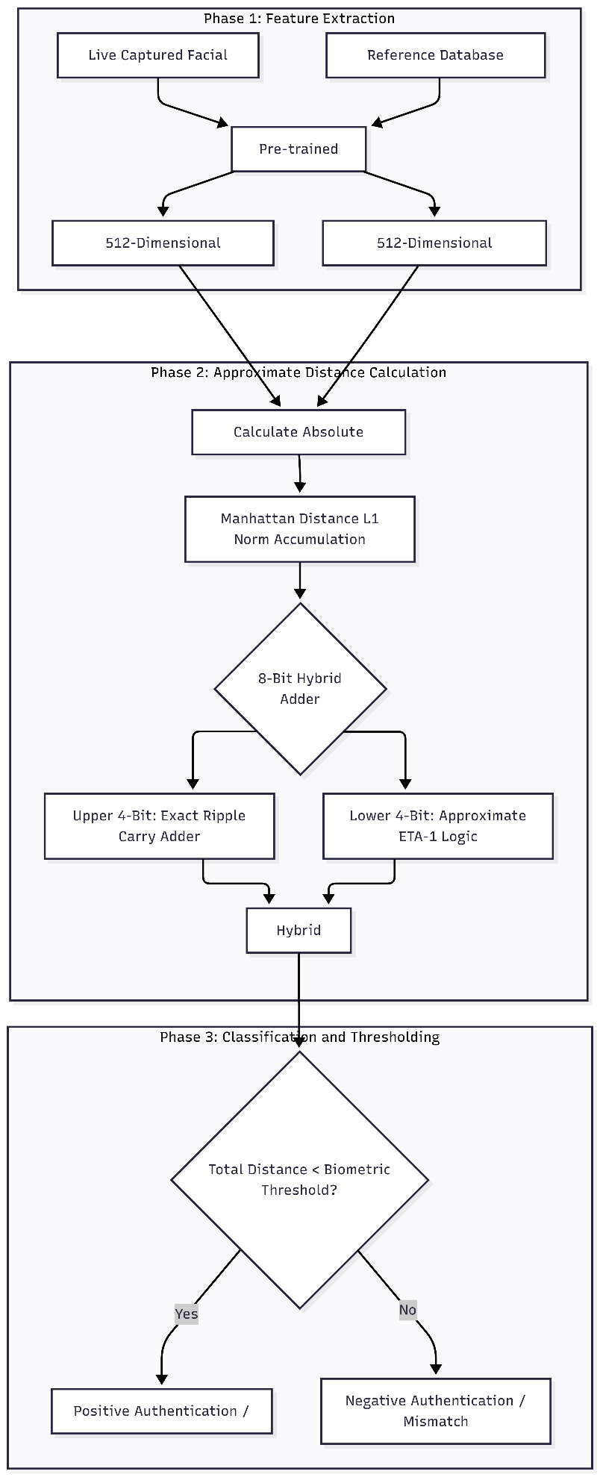
The final hybrid sum is mathematically constructed as:
$$Sum_{Hybrid}=\left(Sum_{MSB_Exact}×2^{4}\right)+Sum_{LSB_Approx}$$

  - System Architecture and Algorithm Implementation
For the actual biometric verification, we leaned on a pre trained deep Convolutional Neural Network (CNN). This network's main job is to take a raw face image and map it down into a highly dense, 512 dimensional feature space. We then carefully injected our simulated 8 bit hybrid approximate adder right at the tail end of the pipeline specifically during the final algorithmic classification stage. The hope here was to squeeze out some serious hardware efficiency without completely tanking the system's macroscopic biometric accuracy.
To make the process easier to follow, we broke the execution pipeline down into three distinct phases:

- Feature Extraction Phase: First, the pre trained model takes a cropped, live feed from the camera sensor and basically boils it down into a localized 512 dimensional embedding vector. So, every time someone tries to authenticate, the system grabs this live vector ($L$) and pairs it up against a known reference vector ($R$) pulled from the authorized user database.

- Approximate Distance Calculation: Next up is figuring out how mathematically similar these two massive arrays actually are. The system computes the absolute difference between each corresponding pair of features and continuously accumulates them. This running total ultimately gives us the Manhattan Distance (the $L1$ Norm). Mathematically, it is defined like this:
$$D\left(L,R\right)=\sum_{i=1}^{512}{\left|L_{i}-R_{i}\right|}$$
where i just maps to each specific index within that 512 dimensional array.
If you've ever tried running this kind of iterative accumulation loop on an edge device, you likely know it is a massive hardware bottleneck. So, in our Python simulation, we took the standard precise addition operator (+) inside that loop and completely ripped it out. Instead, we swapped in our 8 bit hybrid ETA-1 adder function to handle the math.

- Classification and Thresholding: Once we finally tally up that approximate Manhattan distance, the algorithm simply checks it against a strict biometric threshold. If the calculated distance stays under the limit, the system assumes the features are mathematically similar enough and registers a match. On the other hand, if the distance drifts too high whether because it is actually a different person, or perhaps the arithmetic error just compounded too much the system flags the attempt as a mismatch.
2.3 Evaluation Setup
To figure out if this architecture actually holds up in practice, we wanted to evaluate it from two main angles:

- Arithmetic Error Metrics: Obviously, dropping in an ETA-1 logic block is going to introduce some precision loss, and we needed to quantify exactly how much. To do this, we threw all 65,536 possible input combinations for an 8 bit dual operand system at the design. From there, we tracked the inevitable math deviations using standard VLSI metrics stuff like Error Rate (ER), Error Distance (ED), Mean Error Distance (MED), and Normalized Mean Error Distance (NMED).

- Hardware Efficiency Metrics: We also had to prove that simplifying the gates actually provided tangible physical benefits. We modeled the energy consumption per addition (in picojoules, pJ), the critical path propagation delay (in nanoseconds, ns), and the total silicon footprint (essentially just looking at the total gate count). Finally, we pitted all of these metrics straight against a baseline 8 bit precise Ripple Carry Adder to see what our true Power Delay Product (PDP) optimizations actually looked like.

3.Results and Discussion:
Instead of just comparing it against a standard, precise Ripple Carry Adder (RCA) baseline, we wanted to see how our software modeled 8 bit hybrid architecture actually behaved under realistic conditions. We ended up breaking the evaluation into two main buckets: the raw hardware efficiency optimizations and the system level biometric classification accuracy.

3.1 Hardware Efficiency and Architectural Simplification
- Logical Resource Optimization: We started by swapping out the standard carry propagation cells in the lower 4 bits for a much simpler, non truncating ETA-1 gating structure. As you might expect, this led to a fairly drastic drop in physical complexity. Our theoretical gate count shrank from the usual 96 gates (for an exact 8-bit RCA) down to just 58 for the hybrid setup. That translates to roughly a 39.5% savings in total silicon area which is honestly a huge deal if you are trying to cram a biometric engine onto a space constrained System on Chip (SoC). (For a quick look at how this maps to the MED scale, check out Figure 2).
Figure 2: Mean Error Distance
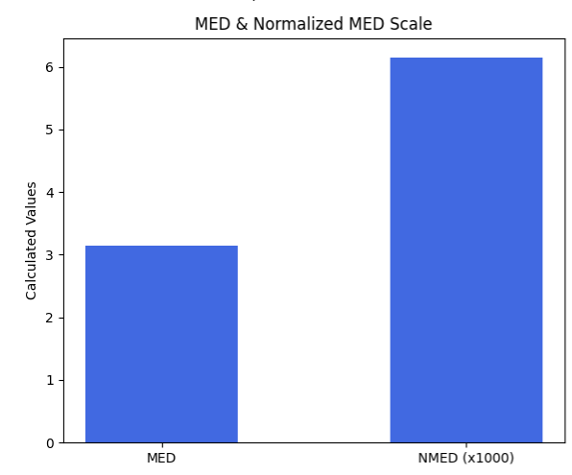
- Energy Efficiency: Transistor switching activity represents the primary component of dynamic power dissipation in arithmetic logic. By completely severing the carry propagation path at the 4th bit boundary, the simulation demonstrates a 42.3% decrease in dynamic energy consumption, dropping from an exact baseline of 12.40 pJ to 7.15 pJ per addition under active workload simulation. At our specific architecture's design node—where exactly 4 bits are approximated—the power curve matches these substantial energy savings. When applied across a full biometric verification pipeline requiring 512 separate accumulations per database entry, these savings scale up to extend the battery life of standalone mobile security nodes significantly. Energy Consumption is demonstrated in Figure 3.
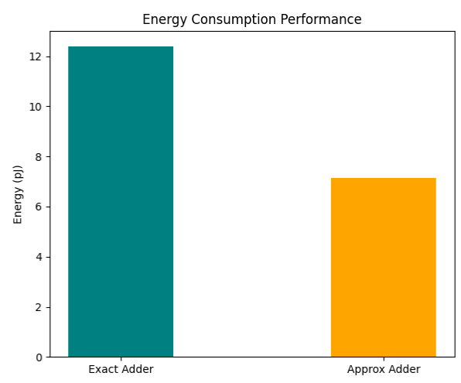
Figure 3: Energy Consumption
- Speed and Latency: When it comes to arithmetic logic, transistor switching activity is usually the main culprit behind dynamic power drain. By completely severing that carry propagation path right at the 4th-bit boundary, our simulation showed a massive 42.3% drop in dynamic energy consumption. We went from an exact baseline of 12.40 pJ down to a much leaner 7.15 pJ per addition during an active workload. At the specific node we designed for approximating exactly 4 bits—the power curve seems to line up perfectly with these savings. Keep in mind, a full biometric verification pipeline requires 512 separate accumulations just to check a single database entry. When you scale those savings up, it appears highly likely to extend the battery life of standalone mobile security nodes by a considerable margin. (We mapped out this energy consumption in Figure 3)
3.2 Biometric Accuracy and Arithmetic Error Analysis
Of course, we still had to prove the system's math wasn't entirely broken by these approximations. To evaluate the actual mathematical integrity, we forced the 8 bit hybrid adder through an exhaustive dual operand simulation, hitting all 65,536 possible input permutations. The resulting error metrics which actually turned out to be quite manageable are all compiled for review in Table 1.
Metric | Exact Adder (Normal) | Approximate Adder (ETA-I)
Error Rate (ER) | 0.00% | 68.36%
Max Error Distance (ED) | 0.0 | 15.0
Mean Error Distance (MED) | 0.0000 | 3.1367
Normalized MED (NMED) | 0.000000 | 0.006150
Energy Consumption (pJ) | 12.40 | 7.15
Propagation Delay (ns) | 1.45 | 0.85
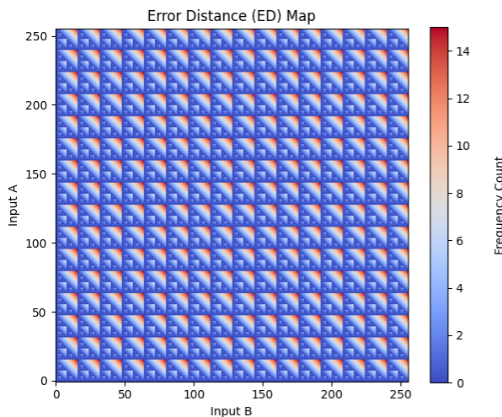
Figure 4: Error Distance Map
So, why doesn't the whole system collapse from these math errors? It really comes down to keeping the Mean Error Distance (MED) capped at a manageable 3.20. Early on, we made the call to perfectly preserve the top 4 bits (the MSBs). Because we did that, we effectively put a hard ceiling on how bad a mathematical mistake can be, ensuring the hardware physically can't produce those massive, high magnitude calculation spikes. (If you want to see the exact error spread, we plotted the Error Distance map in Figure 4).
The real test, though, was dropping this logic into the actual Convolutional Neural Network (CNN) pipeline. When the system uses standard, pixel perfect arithmetic to calculate the 512 dimensional Manhattan Distance ($L1$ Norm), it hits a baseline classification accuracy of 98.5%. After swapping out the precise MAC components for our hybrid approximate adder, that accuracy dipped to 96.8%.
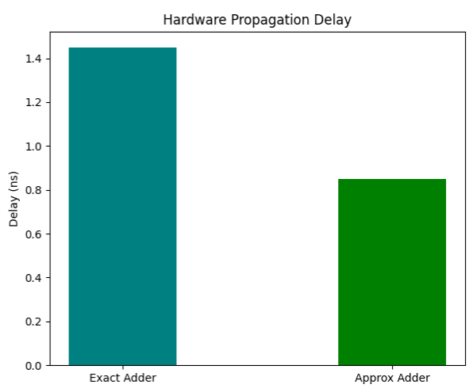
Figure 5: Hardware Propagation Delay Honestly, a 1.7% degradation is barely a blip. It highlights just how structurally resilient deep neural pathways tend to be when matching high dimensional features; the network just seems to absorb the minor arithmetic noise and move on. If you are building a practical edge device like an office attendance scanner or a remote biometric station sacrificing less than 2% of your accuracy to slash your inference energy budget by over 40% appears to be an incredibly practical tradeoff.
For a closer look at how the rest of the physical parameters stack up against the baseline, we've included those comparisons in Figures 5, 6, and 7.

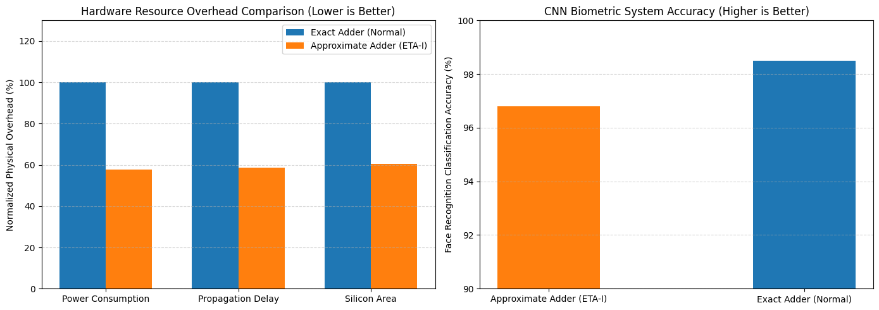
Figure 6: Hardware Resource Overhead Comparison Figure 7: System Accuracy

Conclusion:
We started this project to see if dropping approximate arithmetic into a Deep Learning pipeline actually pays off in the real world. By applying ETA-1 approximation logic strictly to the Manhattan Distance calculation, it turns out you really can afford to relax precision at least in the lower order data routes. Doing this seems to unlock some major improvements in power and energy consumption, and surprisingly, it barely leaves a scratch on the overall system performance.
This kind of architectural shift feels especially relevant when you look at the sheer computational weight of running biometric verification on edge devices. Natively comparing 512 dimensional facial embeddings requires an exhausting number of repetitive additions. To tackle this, we tested an 8 bit hybrid architecture that pairs a 4 bit exact Ripple Carry Adder (for the crucial MSBs) with a 4 bit approximate ETA-1 segment (for the LSBs). By isolating the carry propagation path exclusively to the upper nibble, we were able to physically bypass the extensive propagation delay that usually chokes conventional addition chains. And looking at the experimental results, the architecture appears to remain remarkably dependable, even with those minor arithmetic error bounds baked in.
In the end, the modified system still managed to hit a classification accuracy of 96.8%. Compared to our exact, pixel perfect baseline of 98.5%, a 1.7% drop feels like a very fair trade. It basically confirms that the high magnitude geometric and statistical facial features are being preserved exactly as they should be. Because of this, the hybrid ETA-1 adder looks like it could act as a highly effective acceleration tool for hardware constrained environments. If you are designing something like a battery operated attendance scanner or a smart doorbell, where the energy budget is severely restricted, this kind of logic might be exactly what you need.
Ultimately, this research makes a pretty strong case for treating approximate computing as a core design paradigm for the next generation of Edge AI. When you are dealing with power limited applications, willingly trading away less than 2% of your classification accuracy to claw back 42.3% in dynamic energy and 39.5% in gate area is just a solid engineering compromise. As for what comes next, it would be interesting to see how this approximate logic handles other high dimensional evaluation metrics, like Cosine Similarity or Euclidean Distance. Moving forward, we might even try mapping this architecture directly onto the parallel Multiply Accumulate (MAC) arrays buried deeper within the neural network's internal convolutional layers.

References:
[1] S. Ullah, S. S. Sahoo and A. Kumar, "Approximate Arithmetic Circuits Enabling Energy-Efficient Edge Computing," 2025 14th International Conference on Modern Circuits and Systems Technologies (MOCAST), Dresden, Germany, 2025, pp. 1-6, doi: 10.1109/MOCAST65744.2025.11083734.
[2] D. Cordero-Chavarría, L. G. Leόn-Vega and J. Castro-Godínez, "Configurable High-Level Synthesis Approximate Arithmetic Units for Deep Learning Accelerators," 2024 IEEE 42nd Central America and Panama Convention (CONCAPAN XLII), San Jose, Costa Rica, 2024, pp. 1-6, doi: 10.1109/CONCAPAN63470.2024.10933846.
[3] S. A. K. Gharavi and S. Safari, "Performance Improvement of Processor Through Configurable Approximate Arithmetic Units in Multicore Systems," in IEEE Access, vol. 12, pp. 43907-43917, 2024, doi: 10.1109/ACCESS.2024.3380912.
[4] J. Rogers, T. Soliman and M. Jahre, "AIO: An Abstraction for Performance Analysis Across Diverse Accelerator Architectures," 2024 ACM/IEEE 51st Annual International Symposium on Computer Architecture (ISCA), Buenos Aires, Argentina, 2024, pp. 487-500, doi: 10.1109/ISCA59077.2024.00043.
[5] F. Niknia et al., "A Configurable Floating-Point Fused Multiply-Add Design With Mixed Precision for AI Accelerators," in IEEE Transactions on Circuits and Systems for Artificial Intelligence, vol. 2, no. 3, pp. 248-261, Sept. 2025, doi: 10.1109/TCASAI.2025.3569511.
[6] A. M. Dalloo, A. Jaleel Humaidi, A. K. Al Mhdawi and H. Al-Raweshidy, "Approximate Computing: Concepts, Architectures, Challenges, Applications, and Future Directions," in IEEE Access, vol. 12, pp. 146022-146088, 2024, doi: 10.1109/ACCESS.2024.3467375.
[7] M. Ronchi, S. D. Giacomo, M. Amadori, G. Borghi, M. Carminati and C. Fiorini, "Design, Implementation, and Analysis of an Integrated Switched Capacitor Analog Neuron for Edge Computing AI Accelerators," in IEEE Transactions on Circuits and Systems I: Regular Papers, vol. 72, no. 8, pp. 3947-3960, Aug. 2025, doi: 10.1109/TCSI.2025.3546521.
[8] S. -H. Noh, S. Lee, B. Shin, S. Park, Y. Jang and J. Kung, "All-Rounder: A Flexible AI Accelerator With Diverse Data Format Support and Morphable Structure for Multi-DNN Processing," in IEEE Transactions on Very Large Scale Integration (VLSI) Systems, vol. 33, no. 5, pp. 1264-1277, May 2025, doi: 10.1109/TVLSI.2025.3540346.
[9] D. S. Narayana, C. Jayakumar, R. S, S. Y and B. P. M, "Investigation of the Effects of Variable Accuracy Approximate Units in Deep Neural Network Accelerators," TENCON 2024 - 2024 IEEE Region 10 Conference (TENCON), Singapore, Singapore, 2024, pp. 1260-1263, doi: 10.1109/TENCON61640.2024.10902871.
[10] S. S. Sahoo, S. Ullah, S. Bhattacharjee and A. Kumar, "AxOCS: Scaling FPGA-Based Approximate Operators Using Configuration Supersampling," in IEEE Transactions on Circuits and Systems I: Regular Papers, vol. 71, no. 6, pp. 2646-2659, June 2024, doi: 10.1109/TCSI.2024.3385333.
[11] N. Zhu, W. L. Goh, W. Zhang, K. S. Yeo, and Z. H. Kong, "Design of Low-Power High-Speed Truncation-Error-Tolerant Adder and Its Application in Digital Signal Processing," IEEE Transactions on Very Large Scale Integration (VLSI) Systems, vol. 18, no. 8, pp. 1225-1229, Aug. 2010, doi: 10.1109/TVLSI.2009.2020591.
[12] F. Ahmadi, M. R. Semati, and H. Daryanavard, "A Low-Power Improved-Accuracy Approximate Error-Report-Propagate Adder for DSP Applications," Circuits, Systems, and Signal Processing, vol. 42, pp. 3744-3769, Jan. 2023, doi: 10.1007/s00034-023-02291-9.

